**53.3. Spring Security - Custom Access Denied Page**

**Default Access Denied Page**:

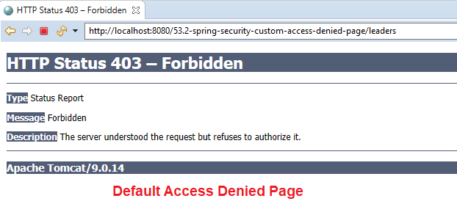

**Custom Access Denied Page**:

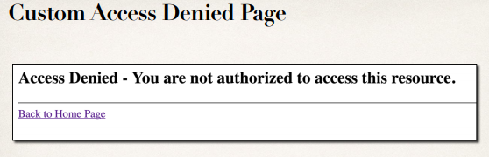

**Development Process (Step-by-Step)**:

1. Configure custom page for access denied
2. Create supporting controller code and view page

**Step-1: Configure custom page for access denied**:

**protected** **void** configure(HttpSecurity http) **throws** Exception {

//Restrict access based on the HttpServletRequest

http.authorizeRequests()

...

.and()

.logout().permitAll()

.and()

// For custom access denied page

.exceptionHandling().accessDeniedPage("/access-denied");

}

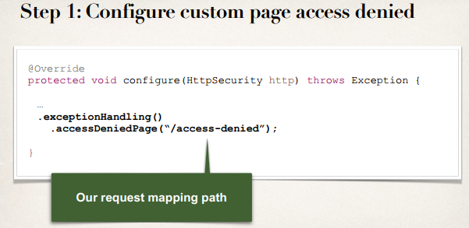

**Step 2: Create Supporting Controller code and View Page**:

**File: LoginController.java**:

@Controller

**public** **class** LoginController {

...

// add request mapping for /access-denied

@GetMapping("/access-denied")

**public** String showAccessDenied() {

**return** "access-denied";

}

}

**File: access-denied.jsp**:

<!DOCTYPE html>

<html>

<head>

<meta charset=*"ISO-8859-1"*>

<title>Custom Access-Denied</title>

</head>

<body>

<h2>Access Denied - You are not authorized to access this resources.</h2>

<hr />

<a href=*"*${pageContext.request.contextPath}*/"*>Back to Home Page</a>

</body>

</html>

53.3. Spring Security - Custom Access Denied Page